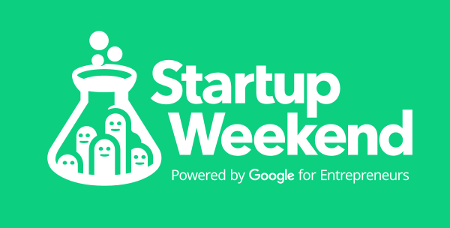

**What is StartUp Weekend?**

**Startup Weekend,** powered by Google for entrepreneurs, is 54-hour weekend event spanning 3 days, during which groups of developers, startup enthusiasts, and more pitch ideas for new startup companies, form teams around those ideas, and work to develop a working prototype, demo, or presentation by Sunday evening. As of December 2016, Startup Weekend has reached 135 countries, involving over 210,000 entrepreneurs.

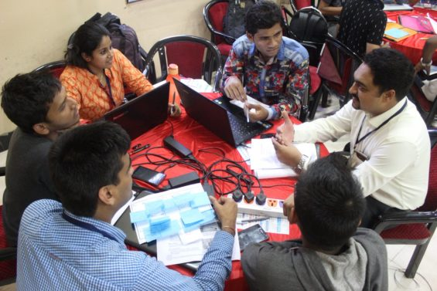

**First StartUp Weekend in Marathwada- SW 2016**

StartUp Weekend is aimed at giving a concrete platform for the youngsters to meet doyens of the industry and know the path for building a successful business model and inspiring them to take the giant leap. With this vision, AAGECA facilitated the first StartUp Weekend in Aurangabad in August, 2016 at GECA for budding entrepreneurs of the city.

Over 50 students and professionals from various disciplines participated in this marathon event of 54 hours. The participants were introduced to the concept of StartUp Weekend by Mr. Vivek Naik from Goa StartUp Community. Amongst the mentors and coaches were Mr. Umesh Dashrathi (MD at Rucha Engineers Pvt. Ltd.) , Ms. Aditi Deshpande (Owner, Exalt Design Hub), Mr. Manoj Kank (Owner, Sangram Auto Components Pvt. Ltd.), Mr. Prasad Takalkar (Company Secretary), and Mr. Vinay Deshpande (retired AGM, State Bank of India).

Self-made entrpreneurs like Muktak Joshi (Vice President and CTO, Ticket Utils), Harshvardhan Agrawal ( Co-founder, YUH Foods) & Pritika Chaterjee (Co-founder, Tidy Homes) were the keynote speakers. Overall event was co-ordinated by Amod Deshpande and student volunteers from GECA.

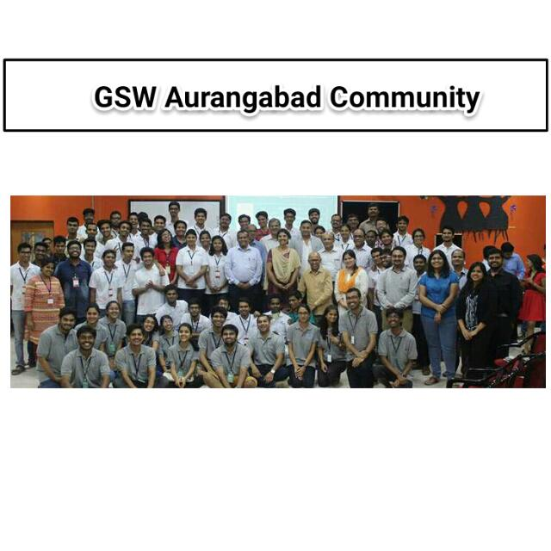

**Outcomes from SW 2016**

Many innovative ideas were pitched before businessmen, industrialists and investors. At the end, PrintOnline (a startup for home-delivered hardcopies of files) Mitow (startup for on-the-spot towing and servicing of vehicles), and Walkie (startup for digital guides for tourists) stood out. The 54-hour marathon concluded with 54 new entrepreneurs who were just the beginning of the now rapidly expanding StartUp Community Aurangabad.

[More about StartUp Weekend Aurangabad held on 12,13 & 14 August 2016…](http://communities.techstars.com/india/aurangabad-maharashtra-india/startup-weekend/9444)